Book Bank Registration

Use case :

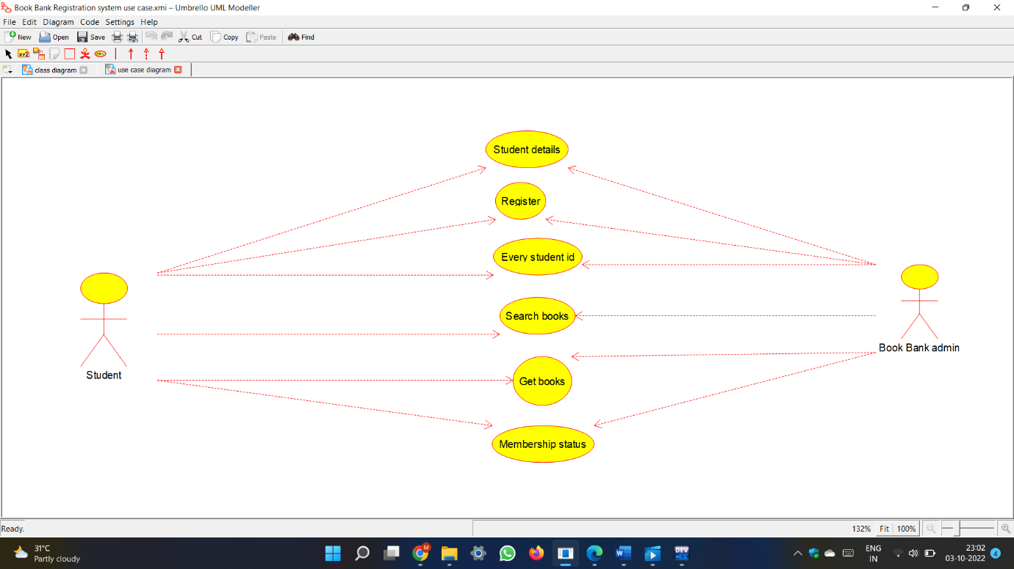

Class diagram :

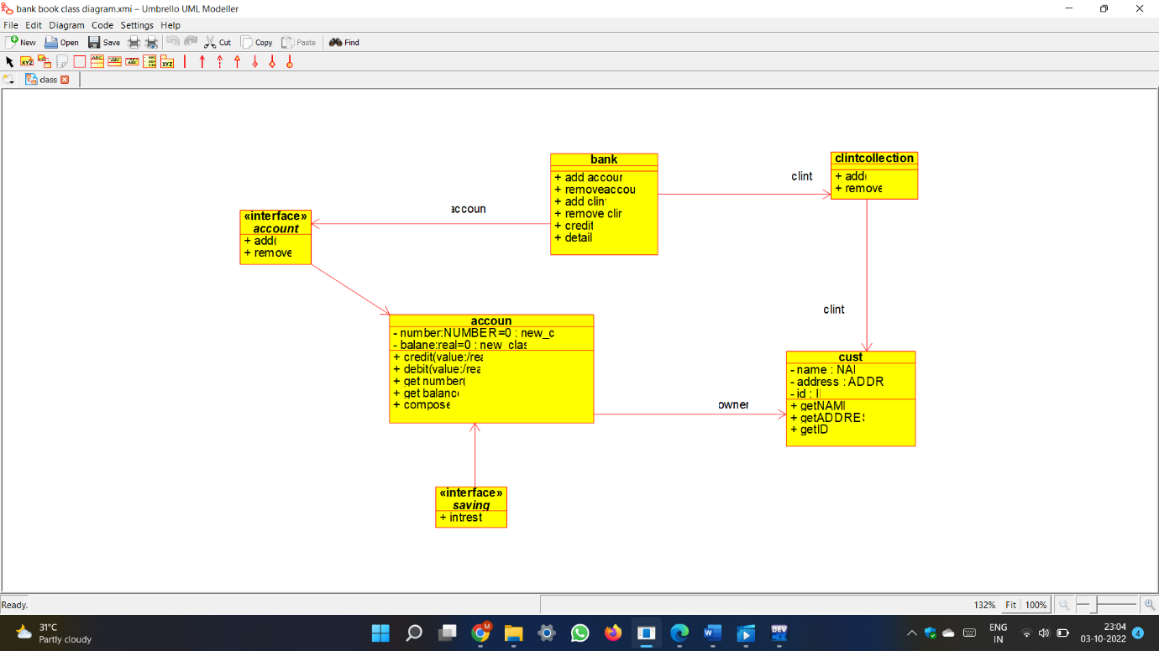

Code :

#ifndef SHIPPING_AGENT_H

#define SHIPPING_AGENT_H

#include <string>

/**

* class shipping_agent

*

*/

class shipping_agent

{

public:

// Constructors/Destructors

//

/**

* Empty Constructor

*/

shipping_agent ();

/**

* Empty Destructor

*/

virtual ~shipping_agent ();

// Static Public attributes

//

// Public attributes

//

// Public attribute accessor methods

//

// Public attribute accessor methods

//

protected:

// Static Protected attributes

//

// Protected attributes

//

public:

// Protected attribute accessor methods

//

protected:

public:

// Protected attribute accessor methods

//

protected:

private:

// Static Private attributes

//

// Private attributes

//

public:

// Private attribute accessor methods

//

private:

public:

// Private attribute accessor methods

//

private:

};

#endif // SHIPPING_AGENT_H

#ifndef SAVING_H

#define SAVING_H

#include <string>

/**

* class saving

*

*/

/******************************* Abstract Class ****************************

saving does not have any pure virtual methods, but its author

defined it as an abstract class, so you should not use it directly.

Inherit from it instead and create only objects from the derived classes

*****************************************************************************/

class saving

{

public:

// Public attribute accessor methods

//

// Public attribute accessor methods

//

/**

*/

virtual void intrest ()

{

}

protected:

public:

// Protected attribute accessor methods

//

protected:

public:

// Protected attribute accessor methods

//

protected:

private:

public:

// Private attribute accessor methods

//

private:

public:

// Private attribute accessor methods

//

private:

};

#endif // SAVING_H

#ifndef ACCOUN_H

#define ACCOUN_H

#include <string>

/**

* class accoun

*

*/

class accoun

{

public:

// Constructors/Destructors

//

/**

* Empty Constructor

*/

accoun ();

/**

* Empty Destructor

*/

virtual ~accoun ();

// Static Public attributes

//

// Public attributes

//

// Public attribute accessor methods

//

// Public attribute accessor methods

//

/**

*/

void credit_value_real_ ()

{

}

/**

*/

void debit_value_real_ ()

{

}

/**

*/

void get_number_ ()

{

}

/**

*/

void get_balance ()

{

}

/**

*/

void compose ()

{

}

protected:

// Static Protected attributes

//

// Protected attributes

//

public:

// Protected attribute accessor methods

//

protected:

public:

// Protected attribute accessor methods

//

protected:

private:

// Static Private attributes

//

// Private attributes

//

new_class_4 number_NUMBER_0;

new_class_5 balane_real_0;

public:

// Private attribute accessor methods

//

private:

public:

// Private attribute accessor methods

//

/**

* Set the value of number_NUMBER_0

* @param new_var the new value of number_NUMBER_0

*/

void setNumber_NUMBER_0 (new_class_4 new_var) {

number_NUMBER_0 = new_var;

}

/**

* Get the value of number_NUMBER_0

* @return the value of number_NUMBER_0

*/

new_class_4 getNumber_NUMBER_0 () {

return number_NUMBER_0;

}

/**

* Set the value of balane_real_0

* @param new_var the new value of balane_real_0

*/

void setBalane_real_0 (new_class_5 new_var) {

balane_real_0 = new_var;

}

/**

* Get the value of balane_real_0

* @return the value of balane_real_0

*/

new_class_5 getBalane_real_0 () {

return balane_real_0;

}

private:

void initAttributes () ;

};

#endif // ACCOUN_H

#ifndef ADDRESS_H

#define ADDRESS_H

#include <string>

/**

* class ADDRESS

*

*/

class ADDRESS

{

public:

// Constructors/Destructors

//

/**

* Empty Constructor

*/

ADDRESS ();

/**

* Empty Destructor

*/

virtual ~ADDRESS ();

// Static Public attributes

//

// Public attributes

//

// Public attribute accessor methods

//

// Public attribute accessor methods

//

protected:

// Static Protected attributes

//

// Protected attributes

//

public:

// Protected attribute accessor methods

//

protected:

public:

// Protected attribute accessor methods

//

protected:

private:

// Static Private attributes

//

// Private attributes

//

public:

// Private attribute accessor methods

//

private:

public:

// Private attribute accessor methods

//

private:

};

#endif // ADDRESS_H

Activity diagram :

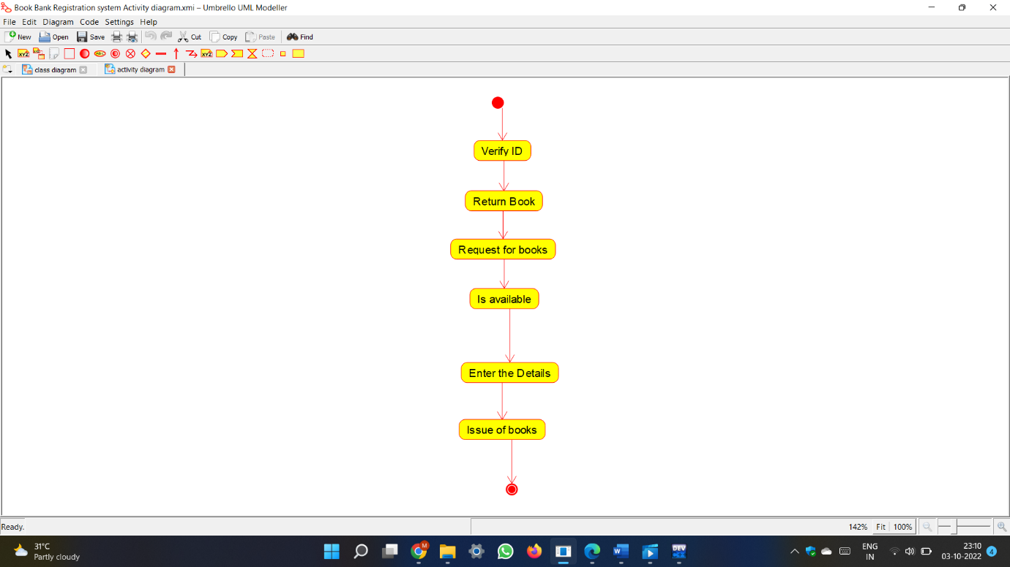

State chart diagram :

